Dynamic Unit
1234 Main St, Naperville, Illinois 60955
312-123-456
tmonacochrsitopher@student.morainepark.edu
www.findyourriffle,com/index

Production Guide

Design Guide 2
3
• Color Scheme ￼ 3
Naming Conventions 3
• Images 3
Formatting of the Code 4
• Template- The overall template of the website is simple. The nav bar has all the different things you can do on the website, and it is easy to understand. 4
Structure/Organization 4
• All the different types of code used- It uses the basics CSS and HTML 4
Page Layout 4
• Navigation- Home, Services, Team, Portfolio, Contact, Login, Client and Employee 4
• Type/Font- Screenshots of different types of fonts used in the code 5
• Sizes/Colors- Screenshots of different type of sizes and colors used in the code 5

Design Guide

Color Scheme 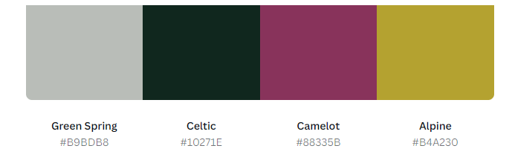

Naming Conventions

Images
Images-


Formatting of the Code

Template- The overall template of the website is simple. The nav bar has all the different things you can do on the website, and it is easy to understand.

Structure/Organization

All the different types of code used- It uses the basics CSS and HTML

Page Layout

Navigation- Home, Services, Team, Portfolio, Contact, Login, Client and Employee

Home- The home page of the website is just a brief overview of what is happening on the site with a contact page.
Services- This gives a brief overview of all the things we do. By this I mean what we can help with.
Team- It goes over all the team members and some things they do in the field as well as a short description about themselves.
Portfolio- This are just examples of projects or things the team members have worked on before.
Contact- It is self-explanatory. It's just a way for anyone to contact the team members
Login- There are two different types of logins. One for the everyday people and then the team login which is used for the people who made the website.
Employee- This goes over what the team has been doing in the last couple months in the team meetings. Also, it has an accountability document on it.

Type/Font- Screenshots of different types of fonts used in the code

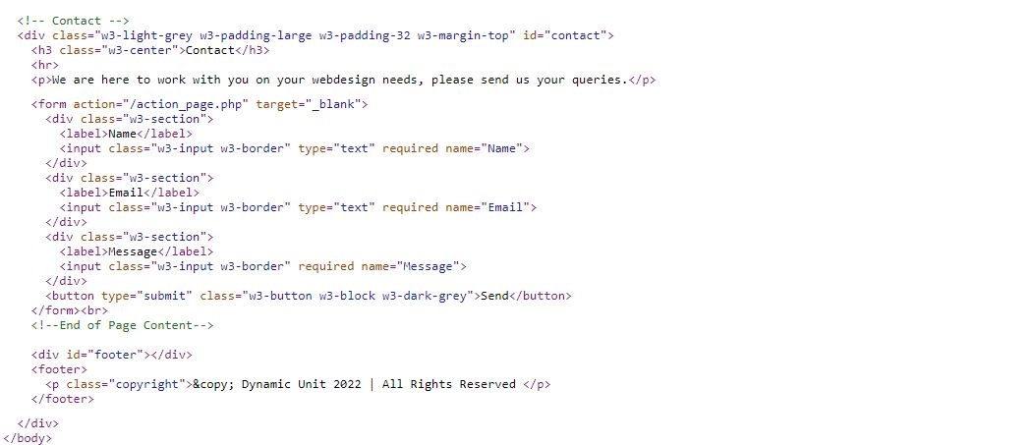

Sizes/Colors- Screenshots of different type of sizes and colors used in the code
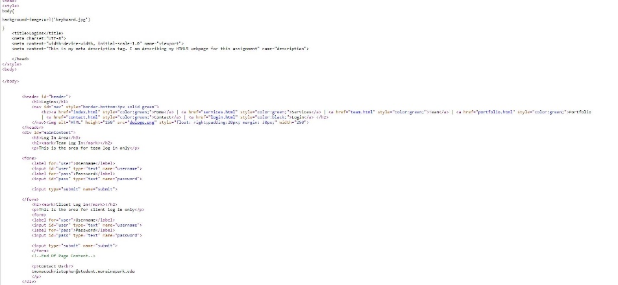
- Navigation- Screenshot of the navigation

